Creating main.py file

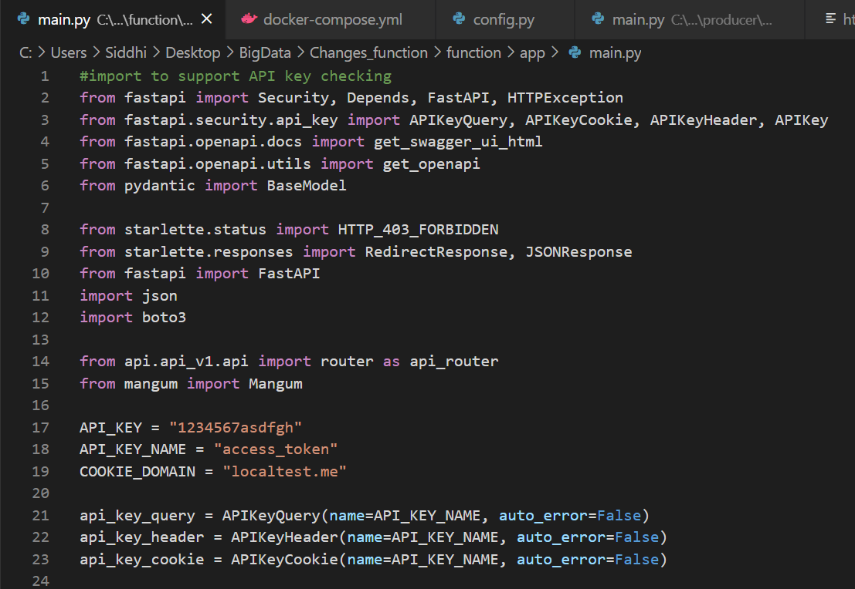

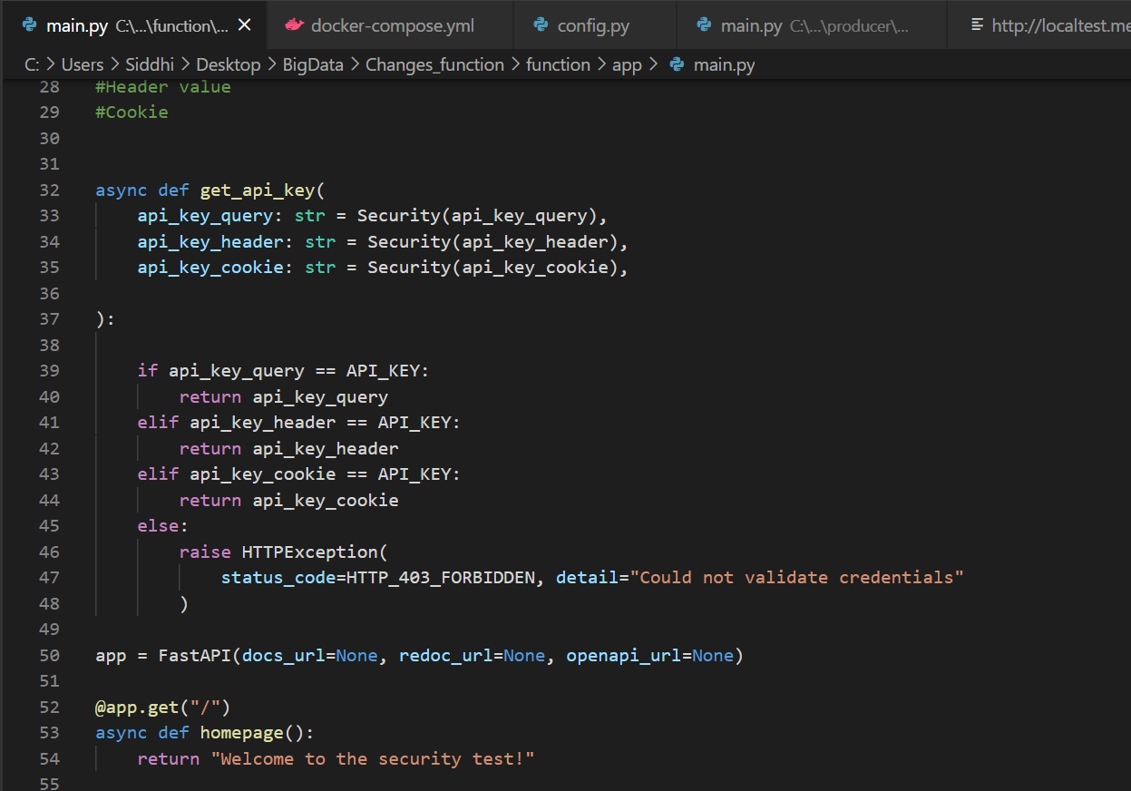

Secure Endpoints:

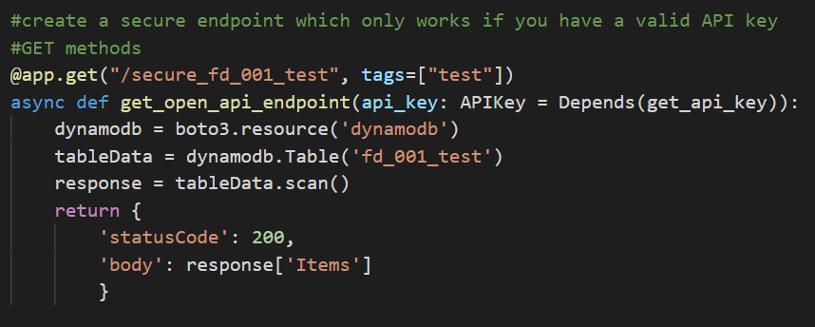

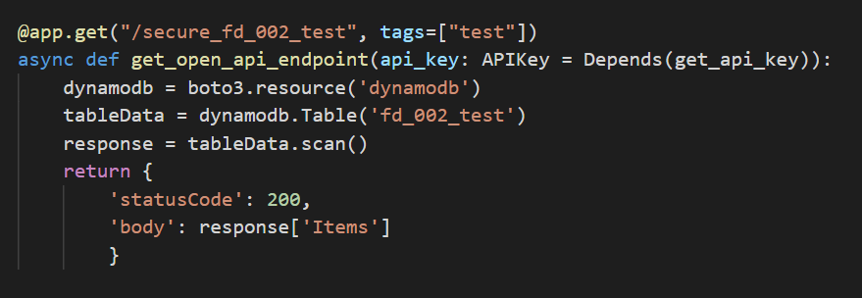

Logout endpoint to clear cookie :

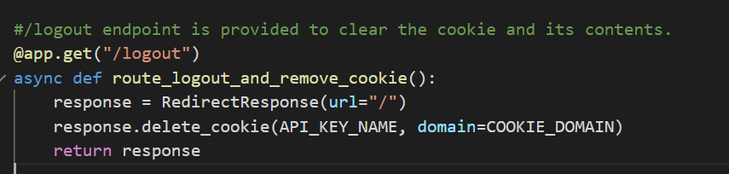

Running the app:-

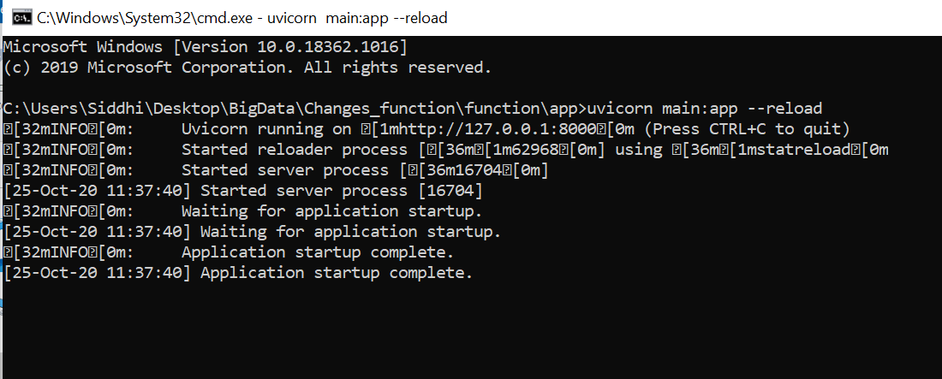

Go to <http://127.0.0.1:8000> – Displays Homepage

Implementation: Enabling API key authentication :

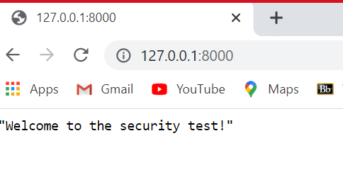

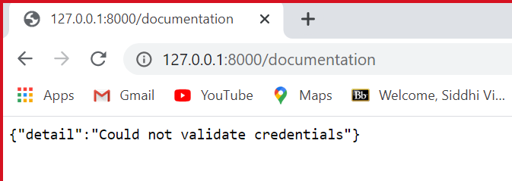

Adding API key in the form of a Query parameter defined as access_token which sets Local cookie containing the API key.

Calling /documentation, without supplying the API key as a query parameter:

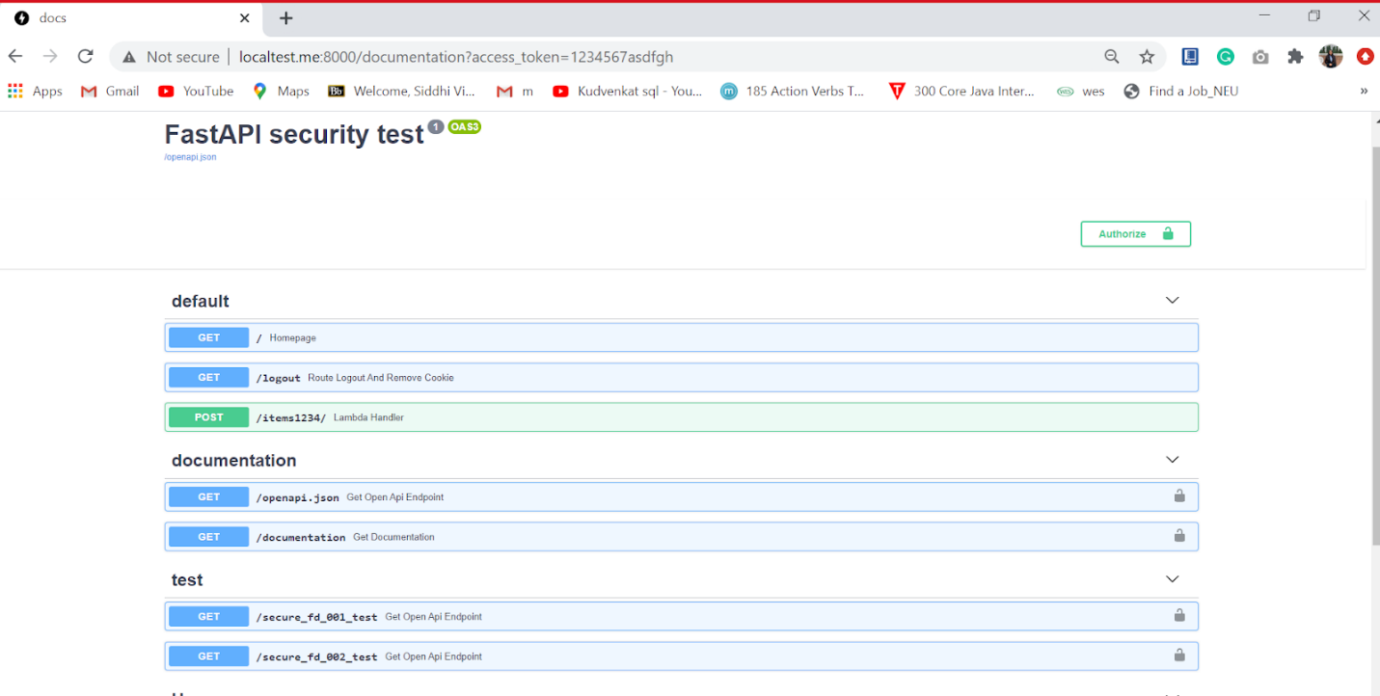

Clear the cookie - http://localtest.me:8000/logout

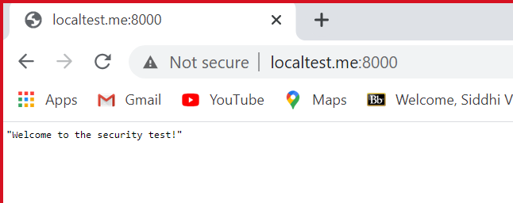

If we go to the /documentation again, we cannot access it anymore

